

BATCH AND ROLL NO:
EXPERIMENT NO.6
TITLE: Design a mobile application to show any website using web view
DATE OF PERFORMANCE
DATE OF CHECKING

Title: Design a mobile application using image slider to show images.

Requirements:
1 Android studio

Theory:

Web View is to deliver a web application as a part of a client application. The WebView class is an extension of Android's View class that allows to display web pages as a part of activity layout. It does not include any features of a fully developed web browser, such as navigation controls or an address bar. All that WebView does, by default, is show a web page.
A common scenario in which using WebView is helpful is when you want to provide information in your app that you might need to update, such as an end-user agreement or a user guide. Within your Android app, you can create an Activity that contains a WebView, then use that to display your document that's hosted online.
Another scenario in which WebView can help is if your app provides data to the user that always requires an Internet connection to retrieve data, such as email. In this case, you might find that it's easier to build a WebView in your Android app that shows a web page with all the user data, rather than performing a network request, then parsing the data and rendering it in an Android layout. Instead, you can design a web page that's tailored for Android devices and then implement a WebView in your Android app that loads the web page.
Steps to follow:
To add a WebView to app, we can either include the <WebView> element in activity layout, or set the entire Activity window as a WebView in onCreate().
Add a WebView in the activity layout
To add a WebView to app in the layout, add the following code to activity's layout XML file:
<WebView android:id="@+id/webview" android:layout_width="match_parent"
android:layout_height="match_parent"
/>
To load a web page in the WebView, use loadUrl(). For example:



Code:

- activity_main.xml

<?xml version="1.0" encoding="utf-8"?>
<androidx.constraintlayout.widget.ConstraintLayout
xmlns:android="http://schemas.android.com/apk/res/android"
xmlns:app="http://schemas.android.com/apk/res-auto"
android:layout_width="match_parent"
android:layout_height="match_parent">
<com.google.android.material.appbar.AppBarLayout
android:id="@+id/appBarLayout"
android:layout_width="match_parent"
android:layout_height="wrap_content"
app:layout_constraintTop_toTopOf="parent">
<androidx.appcompat.widget.Toolbar
android:id="@+id/toolbar"
android:layout_width="match_parent"
android:layout_height="?attr/actionBarSize"
android:background="?attr/colorPrimary"
android:theme="@style/ThemeOverlay.AppCompat.Dark.ActionBar">
<EditText
android:id="@+id/urlEditText"
android:layout_width="match_parent"
android:layout_height="wrap_content"
android:layout_marginEnd="16dp"
android:background="@android:color/white"
android:hint="Enter URL"
android:inputType="textUri"
android:padding="8dp"
android:textColor="@android:color/black"
android:textSize="16sp" />
</androidx.appcompat.widget.Toolbar>
</com.google.android.material.appbar.AppBarLayout>
<ProgressBar
android:id="@+id/progressBar"
style="?android:attr/progressBarStyleHorizontal"
android:layout_width="match_parent"
android:layout_height="3dp"
android:visibility="gone"
app:layout_constraintTop_toBottomOf="@id/appBarLayout" />
<WebView
android:id="@+id/webView"
android:layout_width="match_parent"
android:layout_height="0dp"
app:layout_constraintBottom_toBottomOf="parent"
app:layout_constraintTop_toBottomOf="@id/progressBar" />
</androidx.constraintlayout.widget.ConstraintLayout>

- colors.xml
<?xml version="1.0" encoding="utf-8"?>
<resources>
<!-- Primary Colors -->
<color name="purple_200">#FFBB86FC</color>
<color name="purple_500">#FF6200EE</color>
<color name="purple_700">#FF3700B3</color>


<!-- Secondary Colors -->
<color name="teal_200">#FF03DAC5</color>
<color name="teal_700">#FF018786</color>
<!-- Basic Colors -->
<color name="black">#FF000000</color>
<color name="white">#FFFFFFFF</color>
<!-- Additional UI Colors -->
<color name="gray_light">#FFEEEEEE</color>
<color name="gray_medium">#FFB0B0B0</color>
<color name="gray_dark">#FF666666</color>
<!-- Status Colors -->
<color name="success_green">#FF4CAF50</color>
<color name="error_red">#FFF44336</color>
<color name="warning_yellow">#FFFFC107</color>
<color name="info_blue">#FF2196F3</color>
</resources>

- themes.xml
<resources xmlns:tools="http://schemas.android.com/tools">
<!-- Base application theme. -->
<style name="Base.Theme.Exp6" parent="Theme.Material3.DayNight.NoActionBar">
<!-- Customize your light theme here. -->
<!-- <item name="colorPrimary">@color/my_light_primary</item> -->
<!-- Primary brand color -->
<item name="colorPrimary">@color/purple_500</item>
<item name="colorPrimaryVariant">@color/purple_700</item>
<item name="colorOnPrimary">@color/white</item>
<!-- Secondary brand color -->
<item name="colorSecondary">@color/teal_200</item>
<item name="colorSecondaryVariant">@color/teal_700</item>
<item name="colorOnSecondary">@color/black</item>
<!-- Status bar color -->
<item name="android:statusBarColor">?attr/colorPrimaryVariant</item>
</style>

<style name="Theme.Exp6" parent="Base.Theme.Exp6" />
</resources>

- MainActivity.java
package com.example.exp6;

import android.graphics.Bitmap;
import android.os.Bundle;
import android.view.KeyEvent;
import android.view.View;
import android.view.inputmethod.EditorInfo;
import android.webkit.WebChromeClient;
import android.webkit.WebView;
import android.webkit.WebViewClient;
import android.widget.EditText;
import android.widget.ProgressBar;
import androidx.appcompat.app.AppCompatActivity;
import androidx.appcompat.widget.Toolbar;
public class MainActivity extends AppCompatActivity {
private WebView webView;
private EditText urlEditText;
private ProgressBar progressBar;


@Override
protected void onCreate(Bundle savedInstanceState) {
super.onCreate(savedInstanceState);
setContentView(R.layout.activity_main);
// Initialize UI components
webView = findViewById(R.id.webView);
urlEditText = findViewById(R.id.urlEditText);
progressBar = findViewById(R.id.progressBar);
Toolbar toolbar = findViewById(R.id.toolbar);
setSupportActionBar(toolbar);
// Configure WebView settings
configureWebView();
// Set up URL input handling
setupUrlInput();
// Load a default website
loadUrl("https://www.google.com");
}
private void configureWebView() {
webView.getSettings().setJavaScriptEnabled(true);
webView.getSettings().setDomStorageEnabled(true);
webView.getSettings().setLoadWithOverviewMode(true);
webView.getSettings().setUseWideViewPort(true);
webView.getSettings().setSupportZoom(true);
webView.getSettings().setBuiltInZoomControls(true);
webView.getSettings().setDisplayZoomControls(false);
webView.setWebViewClient(new WebViewClient() {
@Override
public void onPageStarted(WebView view, String url, Bitmap favicon) {
progressBar.setVisibility(View.VISIBLE);
urlEditText.setText(url);
}
@Override
public void onPageFinished(WebView view, String url) {
progressBar.setVisibility(View.GONE);
}
});
webView.setWebChromeClient(new WebChromeClient() {
@Override
public void onProgressChanged(WebView view, int newProgress) {
progressBar.setProgress(newProgress);
}
});
}
private void setupUrlInput() {
urlEditText.setOnEditorActionListener((v, actionId, event) -> {
if (actionId == EditorInfo.IME_ACTION_GO ||
(event != null && event.getKeyCode() == KeyEvent.KEYCODE_ENTER)) {
loadUrl(urlEditText.getText().toString());
return true;
}
return false;
});
}
private void loadUrl(String url) {
if (!url.startsWith("http://") && !url.startsWith("https://")) {
url = "https://" + url;
}
webView.loadUrl(url);


}

@Override
public void onBackPressed() {
if (webView != null && webView.canGoBack()) {
webView.goBack();
} else {
super.onBackPressed();
}
}
}

- AndroidManifest.xml

<?xml version="1.0" encoding="utf-8"?>
<manifest xmlns:android="http://schemas.android.com/apk/res/android"
xmlns:tools="http://schemas.android.com/tools">
<!-- Internet Permission -->
<uses-permission android:name="android.permission.INTERNET"/>
<application
android:allowBackup="true"
android:dataExtractionRules="@xml/data_extraction_rules"
android:fullBackupContent="@xml/backup_rules"
android:icon="@mipmap/ic_launcher"
android:label="@string/app_name"
android:roundIcon="@mipmap/ic_launcher_round"
android:supportsRtl="true"
android:theme="@style/Theme.Exp6">
<activity
android:name=".MainActivity"
android:exported="true">
<intent-filter>
<action android:name="android.intent.action.MAIN" />

<category android:name="android.intent.category.LAUNCHER" />
</intent-filter>
</activity>
</application>

</manifest>


Output:

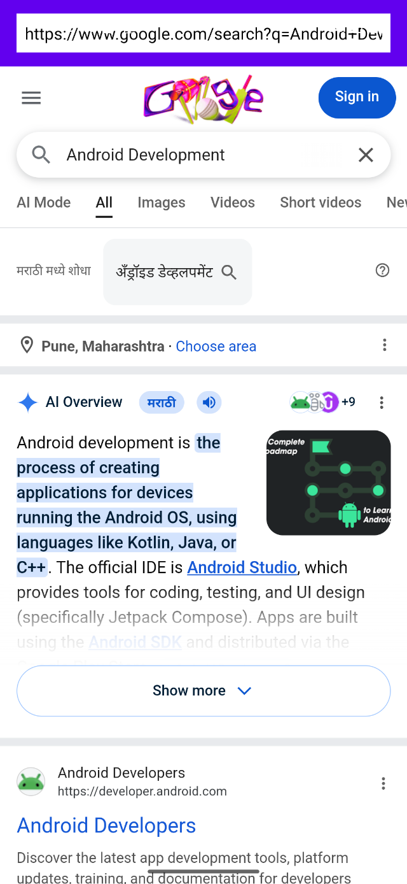 | 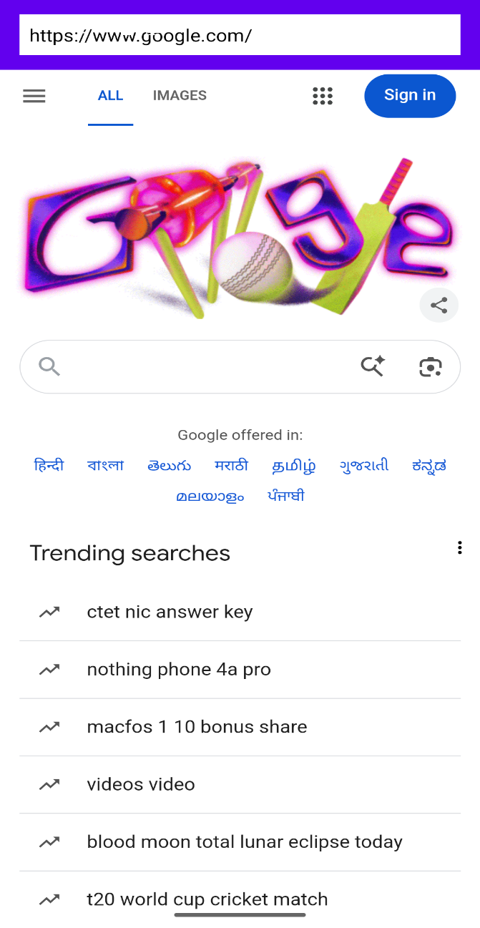

CONCLUSION:

……………………………………………………………………………………………

……………………………………………………………………………………………

……………………………………………………………………………………………



